PRACTICAL-14

Practical Title: Admin Dashboard with Role-Based Access Control, Dynamic Menu, and
Audit Log.

Problem Definition: Develop an admin dashboard that displays user statistics, student count,
event count and latest registrations. Restrict access to admin users only and show dynamic
menu options based on role.

Theory :

1. Are dashboard values loaded dynamically from the database?
Yes. The user count, student count and event count are taken using SQL aggregation queries
such as SELECT COUNT(*). The latest registrations are taken using a JOIN of the
registrations, students and events tables with ORDER BY and LIMIT. No value is written
manually in the code.

2. Is access restricted to admin users?
Yes. At the top of the dashboard page, the session is checked for a logged-in user and the role
must be admin. If not, the user is redirected to the login page or shown an access denied
message.

3. Are role-based menus working?
Yes. The menu is created in PHP according to the role saved in the session. Admin users see
options such as Dashboard, Manage Students, Manage Events, Users and Audit Logs, while
student users see only options such as Profile, Events and My Registrations.

4. Are important admin actions recorded in audit_logs?
Yes. An audit_logs table stores the user id, action, details, IP address and date-time. A
common function is called after important actions such as login, adding, editing or deleting
students and events, and changing user status, so every action can be traced.

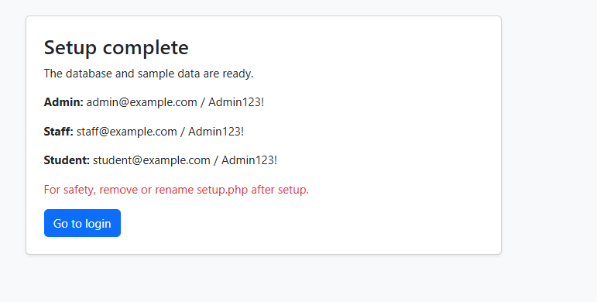
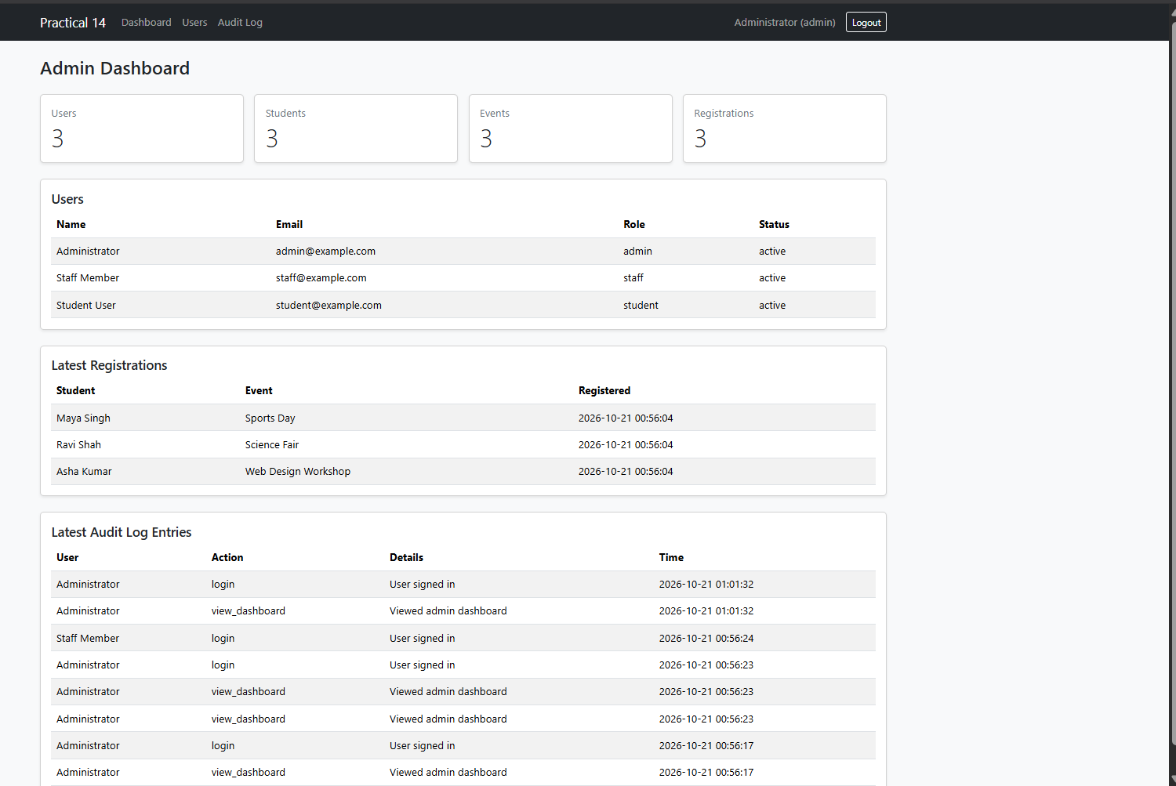

Repository Link :-
https://github.com/meet-3834/Student-Hub/tree/main/FINAL%20Submission

- Learning Outcomes:
I am able to build a role-based admin dashboard with basic monitoring
and traceability.

Faculty Remarks: (Keep this blank for faculty)

